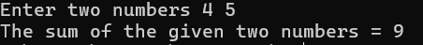
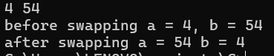
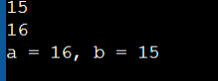
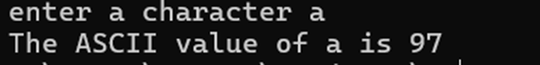
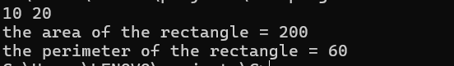
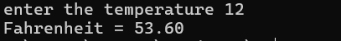
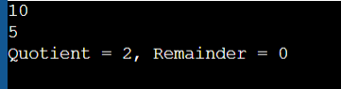
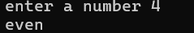
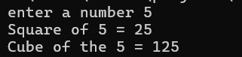
BASIC INPUT AND OUTPUT OPERATORS
- Write a C program to add two integers.

IPO:
Input: Two integers (a, b)
Process: sum = a + b
Output: Sum of the two integers

Code:
#include <stdio.h>
Void main()
{ int a, b, sum;
printf(“enter two numbers:”);
scanf("%d %d", &a, &b);
sum = a + b;
printf("the Sum of the given two numbers= %d\n", sum);
}
Output:
- Write a program to swap two numbers using a temporary variable.
IPO:
Input: Two integers (a, b)
Process: Use temp variable c → c = a; a = b; b = c
Output: Values of a and b after swapping

Code:
#include <stdio.h>
void main()
{
int a, b, c;
scanf("%d %d", &a, &b);
c= a;
a = b;
b = c;
printf("before swapping a= %d, b = %d\n", a, b);
printf(“after swapping a=%d,b=%d\n”,a,b);
}
Output:
- Write a program to swap two numbers without using a temporary variable.
IPO:
Input: Two integers (a, b)
Process: a = a + b; b = a - b; a = a - b
Output: Values of a and b after swapping

Code:
#include <stdio.h>
void main()
{
int a, b;
scanf("%d %d", &a, &b);
a = a + b;
b = a - b;
a = a - b;
printf("a = %d, b = %d\n", a, b);
}
Output:
- Write a program to find the ASCII value of a character.
IPO:
Input: A character (ch)
Process: Get ASCII by printing integer value of ch
Output: ASCII value of the character
Code:
#include <stdio.h>
void main()
{
char ch;
printf(“enter a character”);
scanf(" %c", &ch);
printf("ASCII value of '%c' is %d\n", ch, ch);
}
Output:
- Write a program to calculate the area and perimeter of a rectangle.
IPO:
Input: Length (l) and Width (w) as float
Process: area = l × w; perimeter = 2 × (l + w)
Output: Area and Perimeter
Code:
#include <stdio.h>
void main()
{
float l, w, a, p;
scanf("%f %f", &l, &w);
a = l * w;
p = 2 * (l+ w);
printf("the aera of the rectangle= %.2f\n”,l*w);
printf(“the perimeter of the rectangle=%d”,2*(l+w);
}
Output:
- Write a program to compute the simple interest.
IPO:
Input: Principal (p), Rate (r), Time (t)
Process: si = (p × r × t) / 100
Output: Simple Interest
Code:
#include <stdio.h>
void main()
{
float p, r, t, si;
printf(“enter the values of principles,rate and interest”);
scanf("%f %f %f", &p, &r, &t);
si= (p * r * t) / 100;
printf("Simple Interest = %.2f",si);
}
Output:
- Write a program to convert temperature from Celsius to Fahrenheit.
IPO:
Input: Temperature in Celsius
Process: fahrenheit = (celsius × 9 / 5) + 32
Output: Temperature in Fahrenheit
Code:
#include <stdio.h>
void main()
{
float celsius, fahrenheit;
scanf("%f", &celsius);
printf(“enter the temperature”);
fahrenheit = (celsius * 9 / 5) + 32;
printf("Fahrenheit = %f", fahrenheit);
}
Output:
- Write a program to find the quotient and remainder of two integers.
IPO:
Input: Two integers (a and b or dividend and divisor)
🡒 Process: quotient = a / b; remainder = a % b
🡒 Output: Quotient and Remainder
Code:
#include <stdio.h>
void main()
{
Int a,b, quotient, remainder;
scanf("%d %d", &dividend, &divisor);
quotient =a/b;
remainder =a%b;
printf("Quotient = %d Remainder = %d", quotient, remainder);
}
Output:
- Write a program to check whether a number is even or odd.
IPO:
Input: An integer (num)
Process: Check if num % 2 == 0
Output: "Even" if true, otherwise "Odd"
Code:
#include <stdio.h>
void main()
{
int num;
printf(“enter a number”);
scanf("%d", &num);
if (num % 2 == 0)
printf("%d is Even\n", num);
else
printf("%d is Odd", num);
}
Output:
- Write a program to calculate the square and cube of a number.
IPO:
Input: An integer (num)
Process: square = num × num; cube = num × num × num
Output: Square and Cube
Code:
#include <stdio.h>
void main()
{
int num, s, c;
printf(“enter a number”);
scanf("%d", &num);
s = num * num;
c = num * num * num;
printf("Square of the number = %d\nCube of the number = %d\n", s, c);
}
Output:

